Martin Suzuki A-Segment Car Case Study

QSO-500 Business Research Class Final Project

Matthew DeGiacomo

Southern New Hampshire University

Business Problem

After reading, “Maruti Suzuki India: Defending Market Leadership in the A-Segment”, again there was a problem that stood out to me the most. My research problem for this case study is: New car sales are down two years in a row for Entry Level and Mid-level hatch cars with sales margins being insignificant for those new cars sold compared to used car sales margins. There are many factors that have created this problem that include: increased competition for A Level cars which dilute from Suzuki’s sales and the new car selection, the similarities not differentiating of the customer that buys the new entry level & mid-level hatch , and used car sales becoming a more popular option when buying a car versus a new one. You can see in the chart in example 13 (Mukherjee, Mather, and Dhar, pg 10) that in each year starting in 2008 the overall market share for Suzuki has dropped a total of 7%, 46.51% in 08/09 to 39.12% in 12/13, this is due to the increased competition coming into the market. The more new companies that arrive in the market, the more it is diluting Suzuki’s car sales while also diluting the new car sales market with way to many new cars to choose from. When breaking down the consumers that are the main purchasers of the entry & mid-level hatch new cars there are not many qualities that differentiate them from each other giving almost one class of consumer’s two different levels to choose from compared to the difference in qualities they possess from the high-level consumers. Three qualities stand out to me that are similar for the entry and mid-level car buyers: both cars are usually bought by first time buyers (Mukherjee, Mather, and Dhar, pg 7), in exhibit 1 the consumer’s requirements and specific attributes are generally the same with using terms like value, functionality, and the price ranges being within reason of each other (Mukherjee, Mather, and Dhar, pg 9), and then lastly the entry and mid hatches are both sold outside the top 50 cities and in exhibit 8 the highest attribute that meant a lot to the consumer is price and the least important is style. This means that where these two levels of cars are sold that consumer cares more about price then style. As I read through this case study I determined that nothing has been done by Suzuki to try to solve this problem.

The main stakeholders who would be affected by this problem being solved are following: the customer, the employees, and investors (Thompson, pg1). I gathered these idea from the Ford Motor company CSR Analysis by Andrew Thompson, describing who Ford views as their main stakeholders. In retail, the customer is who drives the business and is the company’s most important priority to keep happy. Next on that list would be the employees who are the ones make the company run smooth, handle the day to day tasks, and help provide the customers with an excellent experience. The investors, they are the people who have a majority stake in the company and are backing the dollars that make the company run. They all the major decision makers and they look to make a profit off the success of the company. Lastly, there a couple more stakeholders to mention including: the vendors who buy the cars from Suzuki who will be affected because they are receiving less product and it shifts their sales cycle. Even the Indian Government can be a stakeholder in this, if there are a certain percentage of people of the public that can be effected and be withheld the opportunity to buy a car from this merger, the government will need to make a move to look out for the people who are effected.

The research objective in this scenario would be to drive overall car sales towards new cars by narrowing the new car selection which in turn would create better margins for new car sales, simplify the customer car buying experience, save money in cost pressures of regulatory compliance (Mukherjee, Mather, and Dhar, pg 8), and also save money in promotions, manufacturing, and storage that was previously used for both entry and mid-level hatch cars. It would benefit the investors because the company would be cutting costs which would help the bottom line. It would help the employees because they would receive better sales margins on new car sales. For the customer, it would help simplify their car buying experience by simplifying the and not overwhelming the customers with so many options.

My research question is: What’s the long term profit impact on overall new car sales, new car sales margins, and entry level and mid-level A hatch cars sales if you were to consolidate the entry and mid-level hatch cars?

The ethical issues for the research questions are few in this study. The ones that stand out would be that of the consumer and the car sales man. The research question would be taking away the most affordable option of a new car and putting the price somewhere in the middle of the entry and mid price point. The salesman would be affected because he would have less options of cars to sell from and less opportunities to make money because his job is based off commission. The data would be collected internally by our analysts who the study and backed up on another drive in case of emergency. The data will be protected and put with a user restriction pass meaning that only people with certain access can the results of the data. I would give just the investors and certain manager employees access to the data because it doesn’t pertain the lower level employees and the customer. To do this experiment, no humans will be tested on and harmed in any way.

Literature Review

There are a couple theories and data that was presented within this case study that help ground my business problem. Due to the intense competition in the market for A Level Hatch cars companies were spending too much money in promotions and reps contracts are to focused on commission which could be helped by consolidating, “With greater choices available in terms of models, features, and brands, sales representatives had a significant role in influencing these choices. For this reason, manufacturers were wooing customers with promotional schemes (sometimes as high a 20 percent of the car price) and compensating their trade channels with hefty sales linked incentive schemes.” (Mukherjee, Mather, and Dhar, pg 6). The next theory which is supported by quantitate data is that sales have gone down from 2010-2013 for both the entry level and mid-level hatch. “See highlighted examples in chart below” (Mukherjee, Mather, and Dhar, pg 9) 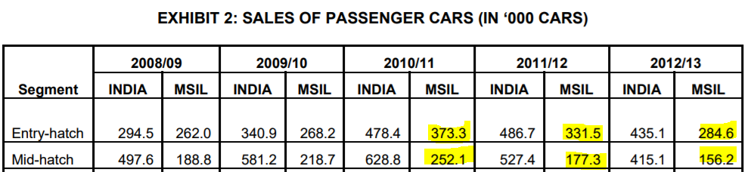

The last theory I will elaborate on is the one that the entry level car is too affordable and needs to sell way too many units to break even compared to its manufacturing costs. “By estimating market price and production costs, the product planning team determined that the entry level hatch would require minimum sales of 300,00 vehicles per year to break even in two years, where the corresponding sales figured for the mid-level hatch and premium hatch were 200,000 and 150,000 respectively.” (Mukherjee, Mather, and Dhar, pg 7).

In this case study there were some limitations that I noticed while reading it according to the literature review section in chapter 4 (Wiley, pg 57). There was question being asked throughout the study. The problem was clear in the sense that MSIL wanted to gain back there market dominance after slipping down the last couple years but there was no main questions being asked. At the bottom of page 8, there are multiple questions being asked that accumulate to a paragraph of words. The case study can be too diluted because they are trying to answer way to many questions and not narrowing down on one. They are also a little biased in this study because its about them and how to get their market dominance back. They are not solving a problem that will impact the community in a positive way or making a contribution the field just themselves.

The case study I looked at that was similar in the sense of trying to drive new car sales in the ever-changing car retail market was the study, “Future of automotive retail” (Miller, R. J., Valsan, A., Zamet, C., Lorenzi, H., & Grant, R. (2015). *Future of Automotive Retail* (pp. 1-12, Publication No. 1). doi:http://www.ey.com/Publication/vwLUAssets/EY-future-of-automotive-retail/$FILE/EY-future-of-automotive-retail.pdf). This case study was about diving into 5 main factors that are going to affect the auto car sale industry and how to prepare for success. The 5 pillars are: “Managing trust and complexity during the customer life cycle, customizing value propositions, creating an engaging digital experience, redesigning distribution networks, and crafting an omni channel brand management strategy.” (Miller, Valsan, Zamet, Lorenzi, Grant, pg 4). One thing that I took from this study that intertwines with Suzuki is the first one about creating trust and keeping the customer engaged during the whole customer cycle so they come back again. According to the study, “72% of consumers feel that an improved buying process would motivate them to visit the dealerships more often” (Miller, Valsan, Zamet, Lorenzi, Grant, pg 5). With Suzuki’s increasing competition having a customer who is a lifelong customer is a top priority not just for that customers business but their families, friends, and referrals. One way Suzuki can do it is to simplify the experience with less cars and not have a pushy sales guys who needs the money to force a customer to buy something they didn’t truly love resulting in a satisfactory experience for them.

In this case study another company who had a similar experience of trying to gain more of the market share for A Level hatch cars is the company TATA NANO. TATO came into the market with new cars and all different type of fancy payment plans like, “Pay First- Drive Later” which backfired on them and then came out with, “Zero down payment option with 4 year/ 64,000 KM guarantee” which helped them. The company came In with new and fresh idea to help sway the customers to their side but their success was limited. “See Exhibit 4 below” (Mukherjee, Mather, and Dhar, pg 10). Their tactics were more gimmicks than sustainable plans so they eventually were not as well received as they hoped to be.

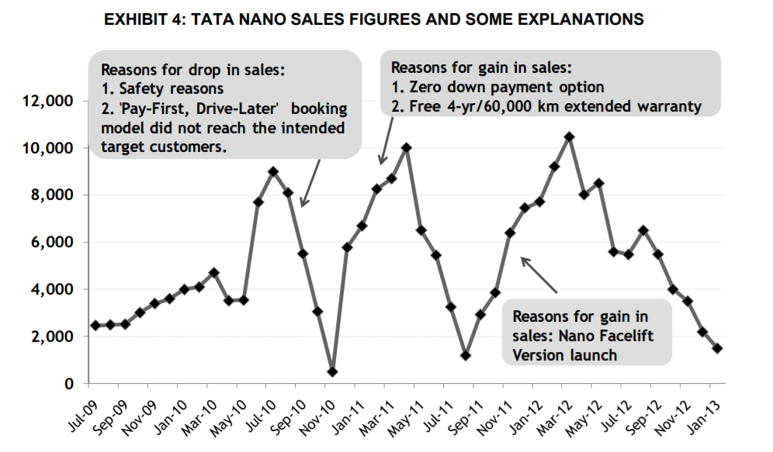

**Research Design**

For this case study I have a four step research design plan that includes 4 different type of research methods that all work into each other sequentially. I want these research methods to be heavily involved with customer reactions data considering this is a customer driven market so more quantitative data than qualitative data in this scenario. My plan and methods go as followed: 1st step: Send a Survey out to all the people via email in Toyota’s database who have ever purchased, looked at, or have been interested in either the entry level hatch and mid-level hatch rather, 2nd step: Survey Groups carefully selected of people who have bought either one of those cars in the past and are lifelong Toyota members as well as a couple unbiased non Toyota customers. This focus group will test drive the current entry/mid-level hatch cars and write a review on each, then test drive the new consolidated model, and then complete a review/comparison chart. 3rd: Based on the feedback from Step 1 & 2, do some experimental interventions, basically create a predictive modeling chart based on the survey and focus groups reactions and predict what you think will happen if we launched the plan. Lastly, if all steps are smooth, implement the plan in smaller markets and test the products and record the numbers. My reasoning for using the fist method of a survey is to get inside how the customer would feel about this transition because at the end of the day it’s a customer driven business and if the customer doesn’t buy the new product then sales will be worse than before. I chose this method as well because it will help us with our predictive modeling on how we think the implantation will go, if we have an idea of how the customer will react it will help us scale it back or forward. For this step I chose people who would actually buy the car or have in the past because they will give their most honest opinion of the car and someone who has no attachment to either car won’t care as much about the survey which will skew the data. Part 2 of plan is focused around the focus group test driving the three vehicles: entry level hatch, mid-level hatch, and the new consolidated model. This way we can have some bias on the reaction to the new one and like my reasoning in step 1, it will give us a better idea for our predicative modeling of the experiment. By running this focus group each person will test drive each of the three cars, write a review and complete the survey from part 1 and then drive the new vehicle. Once the new vehicle has been driven, the teste will complete a comparison chart between the three vehicles and any improvement the company could make on the new consolidated one. Doing this step will also give us some feedback on ways to improve the final model. Step 3 would be running experiments with the feedback we got and predicting what will happen in certain markets if we launched the vehicle. If everything went right, will it fix our original problem or If things went wrong, how much worse will it be. Just running a bunch of different tests of different hypotheticals that can happen using the info from steps 1 & 2 as somewhat of a guideline. Lastly, step 4 is when we implement the consolidated car, record all the numbers down and see the effect it has on our car market.

There are a couple variables that will affect this experiment, its results, and how we determine the results. The key variables in this experiment besides the main independent and dependent variables in this experiment will be: the market city we test in, the target consumer market we go after, and the time of year we introduce the car. The market we test the car in will be determined by the results of where the two cars are the most commonly bought. This information is coming from exhibit 13 (Shukla, H., & Chotai, pg 13). We do this because we want to put the car in a market it would succeed in and give it a chance to have an impact. The next variable is the target customer. This is also correlates with variable one which is the city it has the most potential sale impact. Targeting the right customer is very important and if you target the wrong customer, your experiment will fail. The target customer will include, their attributes they want in a car, mostly their idea money spent for a car, family, and age. How much is that person willing to spend? You can get that information from the customer profile for each level consumer: “Entry level: Annual household income of 300,000 to 500,000, aged 30-34, family with one or two children. Mid-Level: Annual income of 400,000 to 800,000, aged 25-30, unmarried or married with no childen” (Shukla, H., & Chotai, pg 7). Lastly the time of year when we introduce the new car is a key variable, we have to release the car when based on historical sales data those two cars sold the best. Car markets have to be in a good spot for people to even buy the car in the first place.

In the research study, the key dependent variable would be what we are actually doing in this experiment which is consolidating the entry level and mid-level hatch back cars into one car in the hopes of basically driving better sales for those cars. It is what is being measured in this study and what we are testing for. The main independent variable in this experiment would be where we test the cars and people who go after. They are the independent variables because they have a direct effect on the dependent variable. If the consumers don’t buy the car then the car won’t sell is the easiest way to put it. So the independent variable is something you can manipulate and change which is what we are doing. At first we pick and choose the markets and people where we feel based of our research and data that the car will be most successful in.

There are a couple ethical considerations to look at when collecting the data for this experiment. The main one being the use of people private personal information: age, address, phone number, income, email, ect. That is info where if I was released can hurt the company’s reputation and turn people off to buying. This data needs to be protected securely and kept internally with restricted access to high level directors only. Also the people who participated in the survey and focus groups, their identities and info are kept internally not to be released to the public. No humans will be tested on during this experiment and in data collection. But when running number with the predictive modeling we can have an idea two ethical considerations I mentioned in a previous paper. The research question would be taking away the most affordable option of a new car and putting the price somewhere in the middle of the entry and mid-price point. The salesman would be affected because he would have less options of cars to sell from and less opportunities to make money. We can how commissions will be affected as well as if the lower consumer can afford the new car. If we see a problem with both of those, there should be a discussion on whether to move forward or not.

**Data Analysis**

For the data analysis part of the Case Study I came up with numbers on a scale of 1-10 for four different questions that in Milestone 2 I wanted to survey. The four questions went to loyal buyers of these cars and lifelong customers as well as people who have never bought this brand before to have a nice mix of people, they go as followed: What is your opinion on keeping the cars the way they are or if we consolidated them into one car which would be nice and affordable (1 = we don’t like it, 10= yes do it), the next three questions all have to do with this people that we had test drive all three cars: the entry level, the mid-level, and the new merged car. It was based on a scale of 1-10 with 1 being they hated it and 10 being they loved it. I then ran the “descriptive statistics” tool on the Excel Data Analysis tool pack and got: variance, mean, median, mode, Standard deviation, range, etc. Each question has the same 50 participants to keep the data consistent. For the first question the stats showed some interesting facts on the question: it had the highest sum total of all four questions as well as the highest mean average of 5.58 which means people wouldn’t mind seeing a new consolidated car. The mode was 10, which means that people put down a score of 10 the most, so the most put answer was that people are all about the change but just like all 4 questions the range is 9, so as many 10’s as there was there was its fair share of 1 answers. The standard deviation was also the smallest of the 4 questions, with that we can tell that the group of answers was not far from the mean. All in all I would say that the participants would encourage a consolidated hatch back. The next three questions all are comparison questions that each work into each other, comparing how the participants enjoyed driving all three cars, in this scenario, question 2= consolidated car, question 3= entry level car, and question 4 = mid-level car. The question that had the highest sum of all the answers was Q2 with 272, Q4 had 269, Q3 had 265, which says that overall the new car got the higher rating. All the means for these questions are very similar with Q2 having the highest one of 5.44, Q4 with 5.38, and Q3 with 5.3, so no major difference in average score to be able to have an actionable decision but again Q2 did score the highest. The one stat that stood out the most was the mode: Q2 had a mode of 9 so, the second highest option of answers was chosen the most out of the 50 answers on whether they liked the new car, that’s a good sign for the Suzuki. Q3 did not go well with a mode of 1 and Q4 ended up with a solid, so far the entry level car has taken the biggest data hit in unacceptance during the study. Lastly the standard deviation for the latter three questions was again pretty even, Q4 had the smallest one with 2.870611, Q2 was 2.907836, and Q3 ended last being 3.078896 points away from the mean. All in all what I took from these results Is that people are accepting of the new car and encouraging us to do it, there won’t be a ton of backlash because all the voting was merely even but with the consolidated car winning every time. Questions 1 & 2 had the highest modes of 10 & 9 respectively and highest total sums which means that the answer that was put down most were two highest options that are in favor of the consolidated car, from a company perspective this is great news.

I made a couple different charts and graphs with that data that we collected for this experiment. This is one of the most important parts of deciphering through data is being able to take that data and visually present it so it looks clean and easy to understand. The first chart is just a normal plotted line chart showing the scores for Q1: as you can see below, the data is very volatile meaning that it isn’t a consistent upward or downward trend, its random and very balanced, which makes sense as the mean was around 5.5. This to give you a visual of the feedback and to show how many perfect 10 scores there were (8), which is 16% of people are in favor of consolidating the two cars into the one.

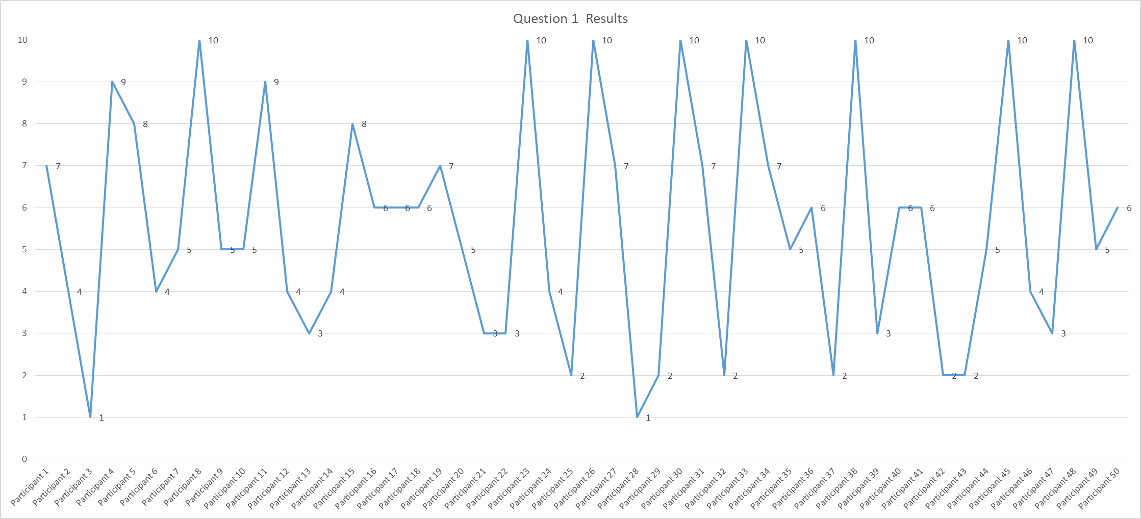

The next chart is a comparison chart between the highest rated original car (Q4/mid-level) and Q2 (new car), it’s a bar graph with the participants scores for the two vehicles combined and then that bar is split up between their Q2 score and Q4 score with the blue half being Q2 and they grey being Q4.

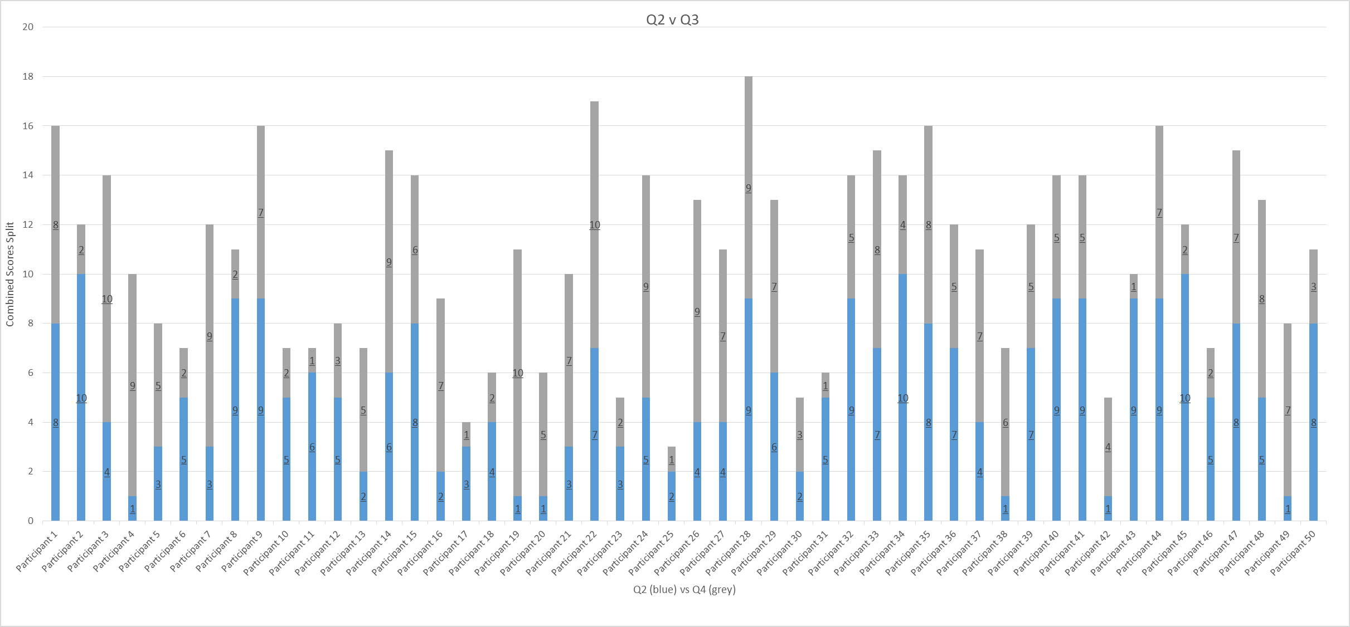

The graph shows comparison of scores between the new car and the mid-level car (highest scored original car). This was close, in sum, mode, and mean but the new car edges out in all three categories: 272 vs 269, 9 vs 7, and 5.44 vs 5.38 respectively. The data has been telling us basically it doesn’t matter what we did the customers feel the same way about the car but if they had to force an answer it would be the new car, now that the customer is ok with it and it makes sense financially, it seems like the way we would lean to go.

For my inferential stats, I chose to do 2 different Z Score Two Sample tests comparing Q2 and Q3 as well as Q2 and Q4. I chose Z score of T because I was dealing with a larger sample size and I was comparing 2 sets of data also I computed the variances of each set for inputting my Z score: Q2 had a 8.2864 variance, Q3 had a 9.29 variance, and Q4 had a 8.0756 variance. I chose the alpha for 5% which equates to a 95% confidence level so whichever the Z score determines as the P(Z<=z) Two-tail score will tell me whether to reject or confirm my null hypothesis which is: Consolidating the entry and mid-level cars into one will benefit everyone from the business to the customers. The bottom chart shows you that the score was .81, so 81% percent true in favor of the null hypothesis when you compare the new car to the entry one.

|  |  |  |
| --- | --- | --- |
|  | *Result (Q2)* | *Result (Q3)* |
| Mean | 5.44 | 5.3 |
| Known Variance | 8.2864 | 9.29 |
| Observations | 50 | 50 |
| Hypothesized Mean Difference | 0 |  |
| z | 0.236128318 |  |
| P(Z<=z) one-tail | 0.40666655 |  |
| z Critical one-tail | 1.644853627 |  |
| P(Z<=z) two-tail | 0.8133331 |  |
| z Critical two-tail | 1.959963985 |  |

When comparing Q2 & Q4 the P(Z<=z) score is .91, which even more supports the hypothesis of combining the cars into one.

The meaning of these were definitely the results we wanted but I did not expect the results to be as close as they were. In the question before driving the car, if they liked the idea of the proposed hypothesis, it was positively received. The customers likes the idea and would not buy from us if we made the move, rather we might get people to switch over to our brand. Looking at the results from next three questions on how they liked the car after they drove it, it clear for me to make a couple assumptions: out of the original cars the entry level got the worst scores and mode of 1, that tells me the customer really only likes it for it price. The mid-level scored the better of the two and had a mode of 7 which tells us that they like the physical nature of the car but not the price but still prefer it over the basic model. With Q2 scoring the best and a mode of 9, it makes sense as this car is the “best of both worlds”, more stylish than the entry but more affordable than the mid-level. The fact that the results were so close was semi comforting, meaning that none of the cars scored bad but also none of them scored through the roof. So people like our cars but don’t love them which you can tell because all the means are around 5.

Some ethics I considered to make this survey fair is first by how I picked my survey group. It was a mix of loyal customers who have bought one of the original two cars in the past (20), people who have never bought from Suzuki before but drive hatch backs (15), and people who have never done either (15). It’s a fair and balanced group of people who don’t have a biased or at the least the whole group doesn’t have a biased on what they like. Their score were made using the “RANDBETWEEN(1-10)” function in excel so every score was totally at random. The results of this survey will only be shared with stakeholders, analysts, and important decision makers who will decide which info to share to the public. The surveyors will be anonymous so their identity will be secret and never shared. The only info that will be shared is the fact that we did a study and got positive reviews which will be a part of the marketing campaign for the new car.

**Conclusions and Recommendations for Action**

Concluding the results of the survey, I have gathered some key conclusions for the stakeholders involved in this project and company that will help us move forward with our case study. When the survey group was asked their option on consolidating the entry & mid-level hatch and if we did how would they feel on scale from 1-10 with 1= hate it and 10= love it. The group answered with mean of 5.58, very balanced, a mode of 10 which is great, 31 people answered 5 or above, and the highest overall sum score. Of the three cars that got test driven (entry, mid, and new) the new car scored the best: having a mean of 5.44, the highest overall score of the test driven cars, a mode of 9, and 30 people choosing the score of 5 or above. All in all, people don’t dislike any of our cars and by the numbers wouldn’t be totally distraught with either decisions we make. So in this scenario I would recommend going ahead with what makes the most sense for us, since that is consolidating, it benefits both parties.

After going through the data and performing a literature review on the case study and the research problem I have definitely learned some new things and my theories were confirmed on some things as well. Something I found out that I was not sure of before was how the customer would react to making a big change like this, I thought they would react negatively. The fact they didn’t was great news, but I don’t think they reacted like this because they are in love with our product, my view on it is, in such large hatchback car market if one company changes something it only effects a part of the market but on the flipside, the fact that it is so competitive, the customer values that a company keeps trying to improve and do what’s best for everyone. Another thing that was new and surprising to me was that all three cars overall tested very closely to each other which shows that no matter what move we make, the buy patterns won’t change that drastically. One thing this did confirm is that people don’t like the entry level with its mode being 1 and less than 30 people choosing the score of 5 and above, the sales stats provoked that theory for me and this data helped confirm it.

Based on this data, the recommendations I want to make is that we should go through with consolidating the entry and mid-level hatch for a new model that is priced and styled with the best of both worlds of those prior cars. Display the findings of the study that positively promote that people feel the way the business does about making this move. We should start discontinuing the older two models, put them on sale to liquidate the inventory as much as we can, and then start to produce and market the new one.

Numbers never lie, debunking stakeholder questions can be a tough task for anyone making a major business change but having your reasoning backed up by proven data is a way to make your point valid. Most of the time stakeholders only care about the bottom line, doing this consolidation will help improve the bottom line and we have data to support that theory. If they still disagree after presenting numbers in my favor, then I would hear them out of why they feel the way they do, discuss as a group to see if anyone else feels the same way, and lastly come to a reasonable compromise on their issue. Additional research that would help would be to do this same study, of same 4 questions in areas where Suzuki Hatchbacks sell the best instead of random. If it has a positive effect on where it already excels then that’s great news. I would also like to see the feedback in a market where the high level hatchback does and markets where the hatchback doesn’t do well overall to get a more broad range of information on the car. I would like the info of us doing a test run of bringing it into a market as well, to give us that last positive affirmation to officially going with it.

**REFERENCES**

* Sekaran, U., & Bougie, R. (2016). *Research Methods for Business* (7th Edition ed.). Chichester, West Sussex: John Whiley & Sons.
* Shukla, H., & Chotai, V. (2017). Turn Around and T through Leadership: A Case of Maruti Suzuki India. *FIIB Business Review,* *6*(2), 19. doi:10.29368/fiib.6.2.2017.19-24
* Morgan, D. L. (2014). Integrating Qualitative and Quantitative Methods: A Pragmatic Approach. doi:10.4135/9781544304533
* Research Methods Guide: Research Design & Method. (n.d.). Retrieved from https://guides.lib.vt.edu/researchmethods/design-method
* Thompson, A. (2017, February 05). Ford Motor Company's Stakeholders: A CSR Analysis. Retrieved from http://panmore.com/ford-motor-company-stakeholders-csr-analysis
* Badenhorst, C. (2018). Citation Practices of Postgraduate Students Writing Literature Reviews. *London Review Of Education*, *16*(1), 121-135.
* Miller, R. J., Valsan, A., Zamet, C., Lorenzi, H., & Grant, R. (2015). *Future of Automotive Retail* (pp. 1-12, Publication No. 1). doi:http://www.ey.com/Publication/vwLUAssets/EY-future-of-automotive-retail/$FILE/EY-future-of-automotive-retail.pdf
* Stake, R. (2009). The case study method in social inquiry. In Gomm, R., Hammersley, M. & Foster, P. Case study method (pp. 18-26). London: SAGE Publications Ltd. doi: 10.4135/9780857024367